**A COMPREHENSIVE ANALYSIS OF FINANCIAL PERFORMANCE INSIGHTS FROM A LEADING BANK**

**PROJECT REPORT**

**SYNOPSIS :**

1. **INTRODUCTION** 
   1. **Overview**
   2. **Purpose**
2. **PROBLEM DEFINITION & DESIGN THINKING**
   1. **Empathy Map**
   2. **Ideation and brainstorming Map**
3. **RESULT**
4. **ADVANTAGES & DISADVANTAGES**
5. **APPLICATIONS**
6. **CONCLUSION**
7. **FUTURE SCOPE**
8. **APPENDIX**

**(SOURCE CODE)**

**INTRODUCTION**

* 1. **Overview**

Based on your initial request, I provided a guide on how to perform a comprehensive financial analysis of the financial performance of a leading bank. I suggested several key financial ratios and metrics that can be used to gain insights into the bank's financial performance, including Return on Assets (ROA), Return on Equity (ROE), Net Interest Margin (NIM), Efficiency Ratio, Asset Quality, and Capital Adequacy. By analyzing these ratios and metrics, you can understand the bank's profitability, asset quality, operating efficiency, and financial stability.

Performing a comprehensive financial analysis of a bank's financial performance requires gathering financial data and analyzing it using various financial ratios and metrics. It is important to compare these ratios and metrics to industry benchmarks and historical trends to gain a complete understanding of the bank's financial performance. Ultimately, the insights gained from a comprehensive financial analysis can help identify areas of strength and weakness within the bank and inform strategic decision-making.

* 1. Purpose

The purpose of the above project is to provide guidance on how to perform a comprehensive financial analysis of the financial performance of a leading bank. The project aims to provide insights into the key financial ratios and metrics that can be used to assess the bank's profitability, asset quality, operating efficiency, and financial stability.

The project is designed to assist financial analysts, investors, and other stakeholders who are interested in understanding the financial performance of a leading bank. By analyzing the financial ratios and metrics discussed in the project, stakeholders can gain insights into the bank's financial performance and make informed decisions regarding investment, lending, and other financial activities.

Overall, the purpose of the project is to provide a framework for analyzing the financial performance of a bank and to facilitate the decision-making process for stakeholders.

Sure, I'd be happy to provide more information on the purpose of the project.

In addition to the guidance on how to perform a comprehensive financial analysis of a leading bank, the project also serves the purpose of highlighting the importance of financial analysis in the banking industry. Financial analysis is a crucial component of the banking industry as it helps stakeholders to identify potential risks and opportunities, make informed investment decisions, and manage their financial resources more effectively.

Moreover, the project aims to highlight the significance of financial analysis in ensuring the long-term financial sustainability of a bank. By analyzing financial ratios and metrics, stakeholders can identify areas where the bank needs improvement and take corrective action to enhance its financial performance.

The project also emphasizes the importance of benchmarking the bank's financial ratios and metrics against its peers and industry standards. This helps stakeholders to determine how the bank is performing relative to its competitors and to identify areas where the bank may be lagging behind.

Overall, the purpose of the project is to provide stakeholders with a comprehensive framework for analyzing the financial performance of a leading bank, emphasizing the importance of financial analysis in the banking industry and in ensuring the long-term financial sustainability of the bank.

**2. PROBLEM DEFINITION & DESIGN THINKING**

2.1 Empathy Map

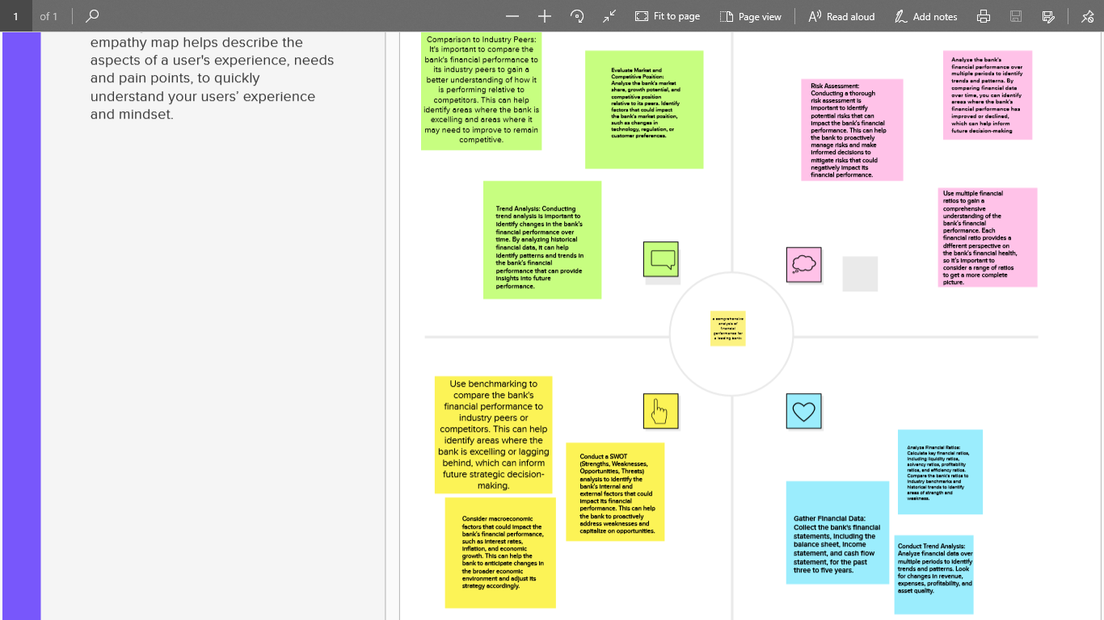

2.2 Ideation and brainstorming map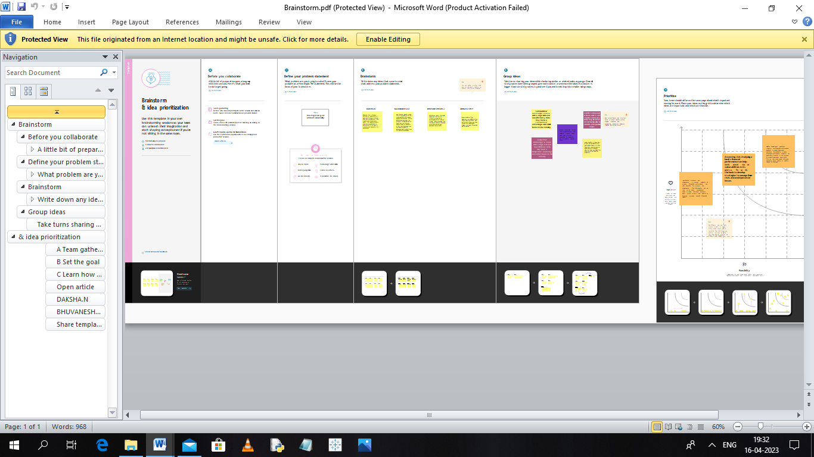

**3.RESULT**

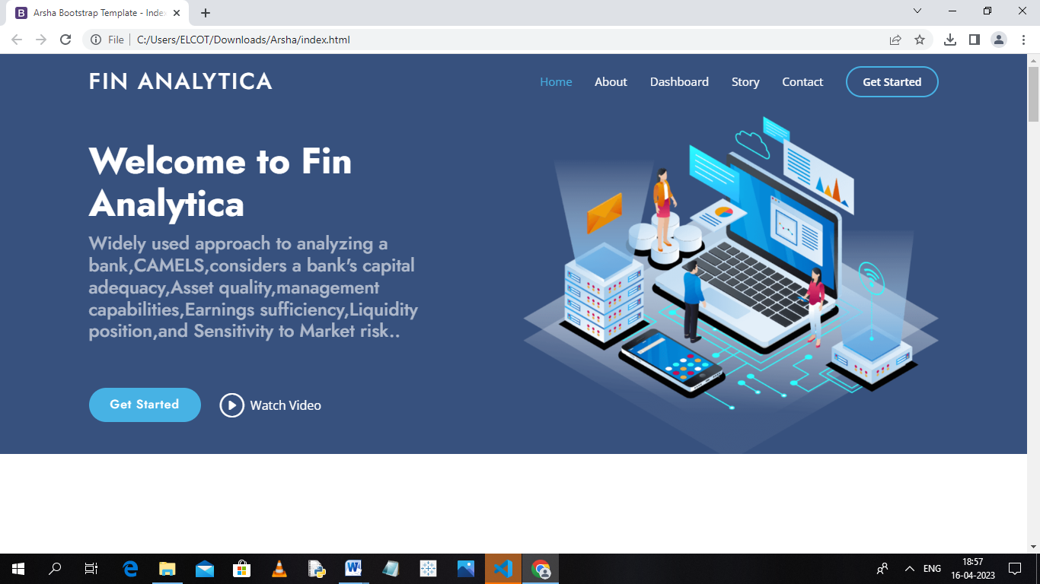

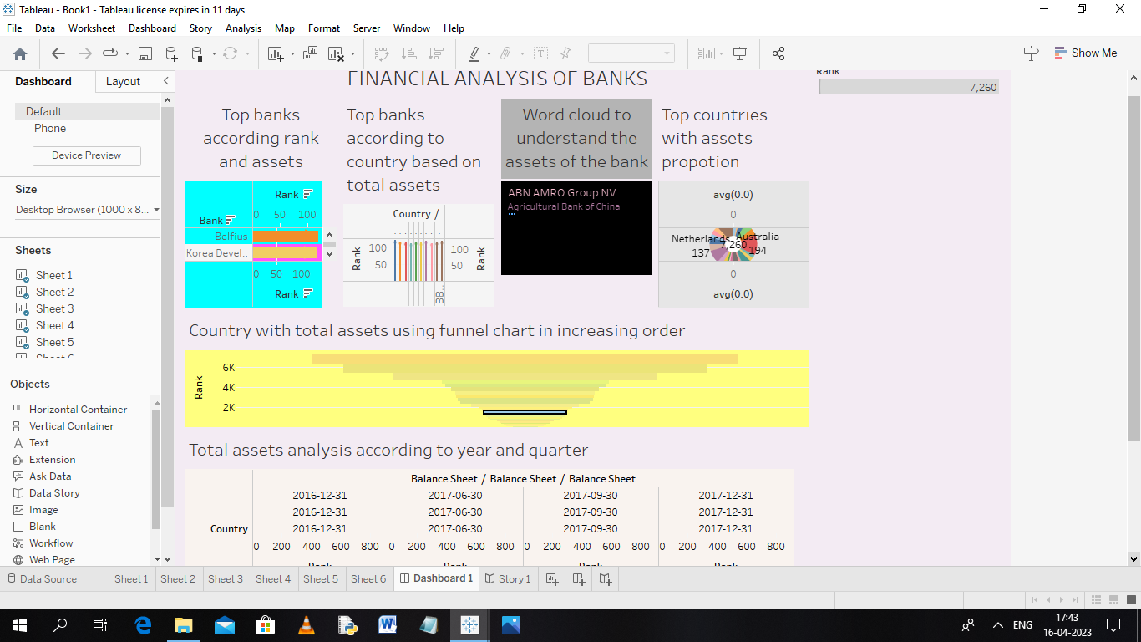

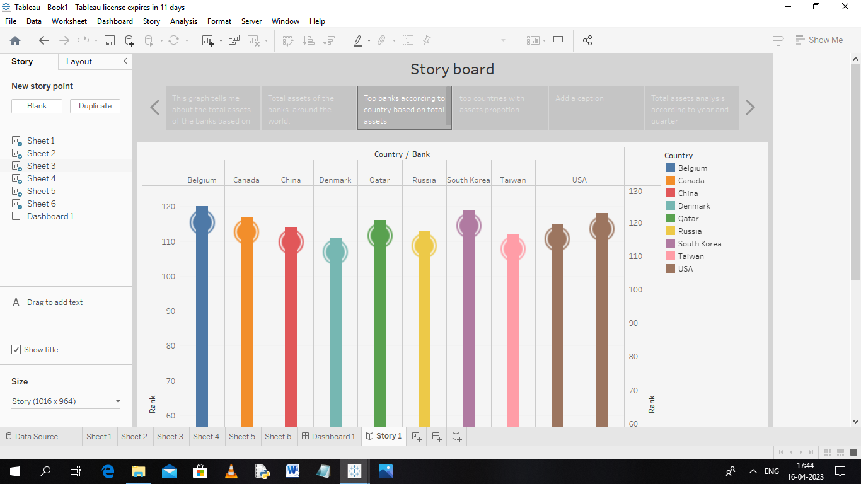

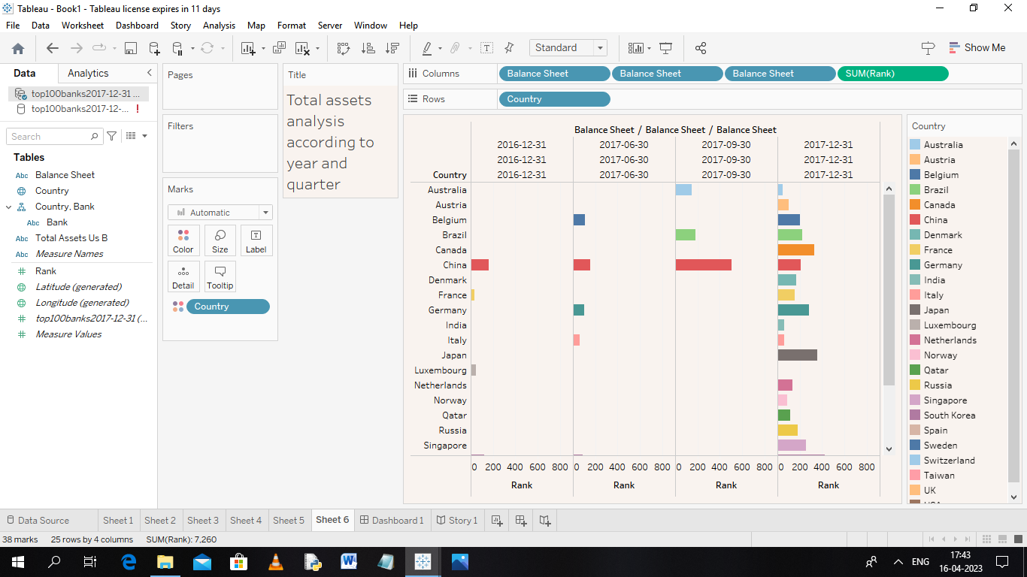

**4. ADVANTAGES & DISADVANTAGES**

Advantages of Comprehensive Analysis of Financial Performance:

* Decision Improved Making: A comprehensive analysis of financial performance *provides a clear picture of a bank's overall financial health. It helps the bank's* management team and other stakeholders make better-informed decisions about the bank's future strategies and operations.
* Identification of Key Issues: By analyzing a bank's financial performance, potential issues or problem areas can be identified. For example, if the bank's profits are declining or if its liquidity is low, these issues can be identified and addressed before they become major problems.
* Comparison with Industry Peers: A comprehensive analysis of financial performance also helps a bank compare its performance with that of its industry peers. This can help the bank identify areas where it is lagging behind and where it needs to improve to remain competitive.
* Increased Transparency: A comprehensive analysis of financial performance also helps to increase transparency, as it provides a clear picture of the bank's financial situation to stakeholders such as investors, regulators, and customers.
* Disadvantages of Comprehensive Analysis of Financial Performance:
* Time-Consuming: Conducting a comprehensive analysis of financial performance can be time-consuming and requires a significant amount of resources, including data and expertise.
* Limited Scope: A comprehensive analysis of financial performance may not capture all aspects of a bank's operations, such as non-financial factors that may be critical to the bank's overall performance.
* Complexity: The financial performance analysis can be complex due
* objectively to avoid potential biases and limitations. **to** the range of financial metrics and ratios involved, which may be difficult for non-financial experts to interpret.
* Potential for Biases: There is a risk of biases or assumptions influencing the analysis, which could lead to incorrect conclusions or recommendations.
* Overall, the advantages of a comprehensive analysis of financial performance outweigh the disadvantages, as it provides valuable insights into a bank's financial health and helps to inform decision-making. However, it is essential to conduct the analysis carefully.

**5. APPLICATIONS**

There are several applications of a comprehensive analysis of financial performance for a leading bank.

Strategy development: A comprehensive analysis of financial performance provides insights that help banks develop strategic plans that are grounded in their financial realities. Banks can use the analysis to identify areas where they need to focus their attention, such as improving efficiency or diversifying their revenue streams.

Risk management: Banks face various risks, such as credit risk, market risk, and operational risk. By analyzing their financial performance, banks can identify potential risks and take steps to mitigate them.

Investor relations: A comprehensive analysis of financial performance is essential for investor relations. Banks can use the analysis to provide investors with an accurate picture of their financial performance and prospects, which can help attract new investors and retain existing ones.

Regulatory compliance: Banks are subject to various regulations that require them to maintain a certain level of financial health. By analyzing their financial performance, banks can ensure that they comply with regulatory requirements.

Benchmarking: Banks can use the analysis to benchmark their performance against that of their competitors. This can help banks identify areas where they are lagging behind and where they need to improve to remain competitive.

Merger and acquisition activity: A comprehensive analysis of financial performance is crucial for merger and acquisition activity. Banks can use the analysis to assess the financial health of potential targets and determine whether they are suitable for acquisition or merger.

Overall, a comprehensive analysis of financial performance provides valuable insights into a bank's financial health and helps inform decision-making across a range of areas, from strategy development to regulatory compliance.

**6. CONCLUSION**

To conclude, a comprehensive analysis of financial performance is an important aspect of a leading bank's operations. It provides valuable insights into the bank's financial health and enables decision-makers to make informed decisions about the bank's future strategies and operations. The analysis helps banks identify potential risks and take steps to mitigate them, prioritize their investments, and ensure that resources are used effectively. By benchmarking their performance against that of their peers, banks can identify areas where they need to improve to remain competitive. Although conducting a comprehensive analysis of financial performance can be complex and time-consuming, the benefits of such an analysis outweigh the disadvantages. It is crucial for banks to maintain their financial health, manage risks, and stay competitive in the industry. Therefore, a comprehensive analysis of financial performance is an essential tool for leading banks to achieve these objectives.

**7. FUTURE SCOPE**

The future scope of comprehensive analysis of financial performance for leading banks is promising. With the advent of new technologies such as Artificial Intelligence (AI), Machine Learning (ML), and Big Data, banks can now process large amounts of data in real-time, enabling them to gain deeper insights into their financial performance. This will allow banks to make faster, more informed decisions about their operations and investments.Moreover, the future of banking is likely to be increasingly focused on sustainability and environmental, social, and governance (ESG) considerations. As such, a comprehensive analysis of financial performance will need to take into account ESG factors and their impact on the bank's financial performance. This will require the development of new analytical frameworks and tools to measure the bank's ESG

performance.Another area of future scope is the integration of financial and non-financial data. Banks will need to integrate data from various sources, such as social media, customer feedback, and environmental data, to gain a holistic view of their performance. This will require the development of new analytical tools and models that can process and analyze these diverse data sources.

Finally, the future of comprehensive analysis of financial performance will also involve greater collaboration between banks and other stakeholders, such as regulators, customers, and investors. This will require banks to develop more transparent reporting frameworks and engage in more open dialogue with these stakeholders.

In conclusion, the future scope of comprehensive analysis of financial performance for leading banks is promising, with new technologies, sustainability considerations, data integration, and stakeholder engagement all set to play a significant role in shaping the future of banking.

**8.APPENDIX**

<!DOCTYPE html>

<html lang="en">

<head>

  <meta charset="utf-8">

  <meta content="width=device-width, initial-scale=1.0" name="viewport">

  <title>Arsha Bootstrap Template - Index</title>

  <meta content="" name="description">

  <meta content="" name="keywords">

  <!-- Favicons -->

  <link href="assets/img/favicon.png" rel="icon">

  <link href="assets/img/apple-touch-icon.png" rel="apple-touch-icon">

  <!-- Google Fonts -->

  <link href="https://fonts.googleapis.com/css?family=Open+Sans:300,300i,400,400i,600,600i,700,700i|Jost:300,300i,400,400i,500,500i,600,600i,700,700i|Poppins:300,300i,400,400i,500,500i,600,600i,700,700i" rel="stylesheet">

  <!-- Vendor CSS Files -->

  <link href="assets/vendor/aos/aos.css" rel="stylesheet">

  <link href="assets/vendor/bootstrap/css/bootstrap.min.css" rel="stylesheet">

  <link href="assets/vendor/bootstrap-icons/bootstrap-icons.css" rel="stylesheet">

  <link href="assets/vendor/boxicons/css/boxicons.min.css" rel="stylesheet">

  <link href="assets/vendor/glightbox/css/glightbox.min.css" rel="stylesheet">

  <link href="assets/vendor/remixicon/remixicon.css" rel="stylesheet">

  <link href="assets/vendor/swiper/swiper-bundle.min.css" rel="stylesheet">

  <!-- Template Main CSS File -->

  <link href="assets/css/style.css" rel="stylesheet">

  <!-- =======================================================

  * Template Name: Arsha

  * Updated: Mar 10 2023 with Bootstrap v5.2.3

  * Template URL: https://bootstrapmade.com/arsha-free-bootstrap-html-template-corporate/

  * Author: BootstrapMade.com

  * License: https://bootstrapmade.com/license/

  ======================================================== -->

</head>

<body>

  <!-- ======= Header ======= -->

  <header id="header" class="fixed-top ">

    <div class="container d-flex align-items-center">

      <h1 class="logo me-auto"><a href="index.html">Fin Analytica</a></h1>

      <!-- Uncomment below if you prefer to use an image logo -->

      <!-- <a href="index.html" class="logo me-auto"><img src="assets/img/logo.png" alt="" class="img-fluid"></a>-->

      <nav id="navbar" class="navbar">

        <ul>

          <li><a class="nav-link scrollto active" href="#hero">Home</a></li>

          <li><a class="nav-link scrollto" href="#about">About</a></li>

          <li><a class="nav-link scrollto" href="#Dashboard">Dashboard</a></li>

          <li><a class="nav-link scrollto" href="#Story">Story</a></li>

          <li><a class="nav-link scrollto" href="#contact">Contact</a></li>

          <li><a class="getstarted s 1. PROBLEM DEFINITION & DESIGN THINKINGcrollto" href="#about">Get Started</a></li>

        </ul>

        <i class="bi bi-list mobile-nav-toggle"></i>

      </nav><!-- .navbar -->

    </div>

  </header><!-- End Header -->

  <!-- ======= Hero Section ======= -->

  <section id="hero" class="d-flex align-items-center">

    <div class="container">

      <div class="row">

        <div class="col-lg-6 d-flex flex-column justify-content-center pt-4 pt-lg-0 order-2 order-lg-1" data-aos="fade-up" data-aos-delay="200">

          <h1>Welcome to Fin Analytica</h1>

          <h2>Widely used approach to analyzing a bank,CAMELS,considers a bank's capital adequacy,Asset quality,management capabilities,Earnings sufficiency,Liquidity position,and Sensitivity to Market risk..</h2>

          <div class="d-flex justify-content-center justify-content-lg-start">

            <a href="#about" class="btn-get-started scrollto">Get Started</a>

            <a href="https://www.youtube.com/watch?v=jDDaplaOz7Q" class="glightbox btn-watch-video"><i class="bi bi-play-circle"></i><span>Watch Video</span></a>

          </div>

        </div>

        <div class="col-lg-6 order-1 order-lg-2 hero-img" data-aos="zoom-in" data-aos-delay="200">

          <img src="assets/img/hero-img.png" class="img-fluid animated" alt="">

        </div>

      </div>

    </div>

  </section><!-- End Hero -->

    <!-- ======= About Us Section ======= -->

    <section id="about" class="about">

      <div class="container" data-aos="fade-up">

        <div class="section-title">

          <h2>About Us</h2>

        </div>

        <div class="row content">

          <div class="col-lg-6">

            <p>

              We provide best Business intelligence solutions to the companies,which makes a strategy for elevating their business in the Market

            </p>

            <ul>

              <li><i class="ri-check-double-line"></i>Insights generations using Business intelligence.</li>

              <li><i class="ri-check-double-line"></i>Building Data Models using statistics.</li>

              <li><i class="ri-check-double-line"></i>Developing the predictive Models.</li>

            </ul>

          </div>

          <div class="col-lg-6 pt-4 pt-lg-0">

            <p>

              The banking industry world-wide is being transformed. The global forces for change include technological

              innovation; the deregulation of financial services at the national level and opening-up to international

              competition; and - equally important - changes in corporate behavior, such as growing disintermediation and

              increased emphasis on shareholder value.

            </p>

            <a href="#" class="btn-learn-more">Learn More</a>

          </div>

        </div>

      </div>

    </section><!-- End About Us Section -->

    <!-- ======= Skills Section ======= -->

    <section id="skills" class="skills">

      <div class="container" data-aos="fade-up">

        <div class="row">

          <div class="col-lg-6 d-flex align-items-center" data-aos="fade-right" data-aos-delay="100">

            <img src="assets/img/skills.png" class="img-fluid" alt="">

          </div>

          <div class="col-lg-6 pt-4 pt-lg-0 content" data-aos="fade-left" data-aos-delay="100">

            <div class="skills-content">

              <div class="progress">

                <span class="skill">1000000     Has successfully completed<i class="val"></i></span>

              </div>

              <div class="progress">

                <span class="skill">300     Projects has been developed <i class="val"></i></span>

              </div>

              <div class="progress">

                <span class="skill">10000 Hours of support has been delivered<i class="val"></i></span>

              </div>

              </div>

            </div>

          </div>

        </div>

      </div>

    </section><!-- End Skills Section -->

    <!-- ======= Services Section ======= -->

    <section id="Dashboard" class="services section-bg">

      <div class="container" data-aos="fade-up">

        <div class="section-title">

          <h2>Dashboard</h2>

          <p>Magnam dolores commodi suscipit. Necessitatibus eius consequatur ex aliquid fuga eum quidem. Sit sint consectetur velit. Quisquam quos quisquam cupiditate. Et nemo qui impedit suscipit alias ea. Quia fugiat sit in iste officiis commodi quidem hic quas.</p>

        </div>

        <div>

          <div class='tableauPlaceholder' id='viz1681543223316' style='position: relative'><noscript><a href='#'><img alt='FINANCIAL ANALYSIS OF BANKS ' src='https:&#47;&#47;public.tableau.com&#47;static&#47;images&#47;bo&#47;book1extract&#47;Dashboard1&#47;1_rss.png' style='border: none' /></a></noscript><object class='tableauViz'  style='display:none;'><param name='host_url' value='https%3A%2F%2Fpublic.tableau.com%2F' /> <param name='embed_code_version' value='3' /> <param name='site_root' value='' /><param name='name' value='book1extract&#47;Dashboard1' /><param name='tabs' value='no' /><param name='toolbar' value='yes' /><param name='static_image' value='https:&#47;&#47;public.tableau.com&#47;static&#47;images&#47;bo&#47;book1extract&#47;Dashboard1&#47;1.png' /> <param name='animate_transition' value='yes' /><param name='display_static_image' value='yes' /><param name='display_spinner' value='yes' /><param name='display_overlay' value='yes' /><param name='display_count' value='yes' /><param name='language' value='en-US' /><param name='filter' value='publish=yes' /></object></div>                <script type='text/javascript'>                    var divElement = document.getElementById('viz1681543223316');                    var vizElement = divElement.getElementsByTagName('object')[0];                    if ( divElement.offsetWidth > 800 ) { vizElement.style.width='1000px';vizElement.style.height='827px';} else if ( divElement.offsetWidth > 500 ) { vizElement.style.width='1000px';vizElement.style.height='827px';} else { vizElement.style.width='100%';vizElement.style.height='1527px';}                     var scriptElement = document.createElement('script');                    scriptElement.src = 'https://public.tableau.com/javascripts/api/viz_v1.js';                    vizElement.parentNode.insertBefore(scriptElement, vizElement);                </script>

        </div>

    <section id="Story" class="services section-bg">

      <div class="container" data-aos="fade-up">

        <div class="section-title">

          <h2>Story</h2>

          <p>Magnam dolores commodi suscipit. Necessitatibus eius consequatur ex aliquid fuga eum quidem. Sit sint consectetur velit. Quisquam quos quisquam cupiditate. Et nemo qui impedit suscipit alias ea. Quia fugiat sit in iste officiis commodi quidem hic quas.</p>

        </div>

      <div class='tableauPlaceholder' id='viz1681548601060' style='position: relative'><noscript><a href='#'><img alt='Story board ' src='https:&#47;&#47;public.tableau.com&#47;static&#47;images&#47;bo&#47;book1extract&#47;Story1&#47;1_rss.png' style='border: none' /></a></noscript><object class='tableauViz'  style='display:none;'><param name='host_url' value='https%3A%2F%2Fpublic.tableau.com%2F' /> <param name='embed_code_version' value='3' /> <param name='site_root' value='' /><param name='name' value='book1extract&#47;Story1' /><param name='tabs' value='no' /><param name='toolbar' value='yes' /><param name='static_image' value='https:&#47;&#47;public.tableau.com&#47;static&#47;images&#47;bo&#47;book1extract&#47;Story1&#47;1.png' /> <param name='animate_transition' value='yes' /><param name='display_static_image' value='yes' /><param name='display_spinner' value='yes' /><param name='display_overlay' value='yes' /><param name='display_count' value='yes' /><param name='language' value='en-US' /><param name='filter' value='publish=yes' /></object></div>                <script type='text/javascript'>                    var divElement = document.getElementById('viz1681548601060');                    var vizElement = divElement.getElementsByTagName('object')[0];                    vizElement.style.width='1016px';vizElement.style.height='991px';                    var scriptElement = document.createElement('script');                    scriptElement.src = 'https://public.tableau.com/javascripts/api/viz_v1.js';                    vizElement.parentNode.insertBefore(scriptElement, vizElement);                </script></div>

      </div>

    </section><!-- End Services Section -->

    <!-- ======= Cta Section ======= -->

    <section id="cta" class="cta">

      <div class="container" data-aos="zoom-in">

        <div class="row">

          <div class="col-lg-9 text-center text-lg-start">

            <h3>Call To Action</h3>

            <p> Duis aute irure dolor in reprehenderit in voluptate velit esse cillum dolore eu fugiat nulla pariatur. Excepteur sint occaecat cupidatat non proident, sunt in culpa qui officia deserunt mollit anim id est laborum.</p>

          </div>

          <div class="col-lg-3 cta-btn-container text-center">

            <a class="cta-btn align-middle" href="#">Call To Action</a>

          </div>

        </div>

      </div>

    </section><!-- End Cta Section -->

    <!-- ======= Contact Section ======= -->

    <section id="contact" class="contact">

      <div class="container" data-aos="fade-up">

        <div class="section-title">

          <h2>Contact</h2>

          <p>Magnam dolores commodi suscipit. Necessitatibus eius consequatur ex aliquid fuga eum quidem. Sit sint consectetur velit. Quisquam quos quisquam cupiditate. Et nemo qui impedit suscipit alias ea. Quia fugiat sit in iste officiis commodi quidem hic quas.</p>

        </div>

        <div class="row">

          <div class="col-lg-5 d-flex align-items-stretch">

            <div class="info">

              <div class="address">

                <i class="bi bi-geo-alt"></i>

                <h4>Location:</h4>

                <p>KGCAS, Saravanampatti,Coimbatore-641035</p>

              </div>

              <div class="email">

                <i class="bi bi-envelope"></i>

                <h4>Email:</h4>

                <p>info@kgcas.com</p>

              </div>

              <div class="phone">

                <i class="bi bi-phone"></i>

                <h4>Call:</h4>

                <p>+912364748347</p>

              </div>

          </div>

          <div class="col-lg-7 mt-5 mt-lg-0 d-flex align-items-stretch">

            <form action="forms/contact.php" method="post" role="form" class="php-email-form">

              <div class="row">

                <div class="form-group col-md-6">

                  <label for="name">Your Name</label>

                  <input type="text" name="name" class="form-control" id="name" required>

                </div>

                <div class="form-group col-md-6">

                  <label for="name">Your Email</label>

                  <input type="email" class="form-control" name="email" id="email" required>

                </div>

              </div>

              <div class="form-group">

                <label for="name">Subject</label>

                <input type="text" class="form-control" name="subject" id="subject" required>

              </div>

              <div class="form-group">

                <label for="name">Message</label>

                <textarea class="form-control" name="message" rows="10" required></textarea>

              </div>

              <div class="my-3">

                <div class="loading">Loading</div>

                <div class="error-message"></div>

                <div class="sent-message">Your message has been sent. Thank you!</div>

              </div>

              <div class="text-center"><button type="submit">Send Message</button></div>

            </form>

          </div>

        </div>

      </div>

    </section><!-- End Contact Section -->

  </main><!-- End #main -->

  <!-- ======= Footer ======= -->

  <footer id="footer">

    <div class="footer-newsletter">

      <div class="container">

        <div class="row justify-content-center">

          <div class="col-lg-6">

            <h4>Join Our Newsletter</h4>

            <p>Tamen quem nulla quae legam multos aute sint culpa legam noster magna</p>

            <form action="" method="post">

              <input type="email" name="email"><input type="submit" value="Subscribe">

            </form>

          </div>

        </div>

      </div>

    </div>

    <div class="footer-top">

      <div class="container">

        <div class="row">

          <div class="col-lg-3 col-md-6 footer-contact">

            <h3>Arsha</h3>

            <p>

              KGCAS <br>

              Saravanampatti,Coimbatore-641035<br>

              India <br><br>

              <strong>Phone:</strong> +9123455433565<br>

              <strong>Email:</strong> info@kgcas.com<br>

            </p>

          </div>

          <div class="col-lg-3 col-md-6 footer-links">

            <h4>Useful Links</h4>

            <ul>

              <li><i class="bx bx-chevron-right"></i> <a href="#">Home</a></li>

              <li><i class="bx bx-chevron-right"></i> <a href="#">About us</a></li>

              <li><i class="bx bx-chevron-right"></i> <a href="#">Services</a></li>

              <li><i class="bx bx-chevron-right"></i> <a href="#">Terms of service</a></li>

              <li><i class="bx bx-chevron-right"></i> <a href="#">Privacy policy</a></li>

            </ul>

          </div>

          <div class="col-lg-3 col-md-6 footer-links">

            <h4>Our Services</h4>

            <ul>

              <li><i class="bx bx-chevron-right"></i> <a href="#">Web Design</a></li>

              <li><i class="bx bx-chevron-right"></i> <a href="#">Web Development</a></li>

              <li><i class="bx bx-chevron-right"></i> <a href="#">Product Management</a></li>

              <li><i class="bx bx-chevron-right"></i> <a href="#">Marketing</a></li>

              <li><i class="bx bx-chevron-right"></i> <a href="#">Graphic Design</a></li>

            </ul>

          </div>

          <div class="col-lg-3 col-md-6 footer-links">

            <h4>Our Social Networks</h4>

            <p>We Provide solutions to Your Business</p>

            <div class="social-links mt-3">

              <a href="#" class="twitter"><i class="bx bxl-twitter"></i></a>

              <a href="#" class="facebook"><i class="bx bxl-facebook"></i></a>

              <a href="#" class="instagram"><i class="bx bxl-instagram"></i></a>

              <a href="#" class="google-plus"><i class="bx bxl-skype"></i></a>

              <a href="#" class="linkedin"><i class="bx bxl-linkedin"></i></a>

            </div>

          </div>

        </div>

      </div>

    </div>

    <div class="container footer-bottom clearfix">

      <div class="copyright">

        &copy; Copyright <strong><span>Arsha</span></strong>. All Rights Reserved

      </div>

      <div class="credits">

        <!-- All the links in the footer should remain intact. -->

        <!-- You can delete the links only if you purchased the pro version. -->

        <!-- Licensing information: https://bootstrapmade.com/license/ -->

        <!-- Purchase the pro version with working PHP/AJAX contact form: https://bootstrapmade.com/arsha-free-bootstrap-html-template-corporate/ -->

        Designed by <a href="https://bootstrapmade.com/">BootstrapMade</a>

      </div>

    </div>

  </footer><!-- End Footer -->

  <div id="preloader"></div>

  <a href="#" class="back-to-top d-flex align-items-center justify-content-center"><i class="bi bi-arrow-up-short"></i></a>

  <!-- Vendor JS Files -->

  <script src="assets/vendor/aos/aos.js"></script>

  <script src="assets/vendor/bootstrap/js/bootstrap.bundle.min.js"></script>

  <script src="assets/vendor/glightbox/js/glightbox.min.js"></script>

  <script src="assets/vendor/isotope-layout/isotope.pkgd.min.js"></script>

  <script src="assets/vendor/swiper/swiper-bundle.min.js"></script>

  <script src="assets/vendor/waypoints/noframework.waypoints.js"></script>

  <script src="assets/vendor/php-email-form/validate.js"></script>

  <!-- Template Main JS File -->

  <script src="assets/js/main.js"></script>

</body>

</html>